Week 1 - Assignment 2
github

Core Java Task
- The method calculateTax() is not a pure function.
A pure function must:
- Always return the same output for the same input.
- Not depend on or modify any external (non-local) state.
The method uses rate, which is an instance variable (external state). If rate is changed elsewhere (e.g., through another method or directly), the same amount input would produce different outputs. Hence, it depends on mutable external state, making it impure.

To make it pure, use only its input parameters. The same input values always produce the same output. No external state is involved.
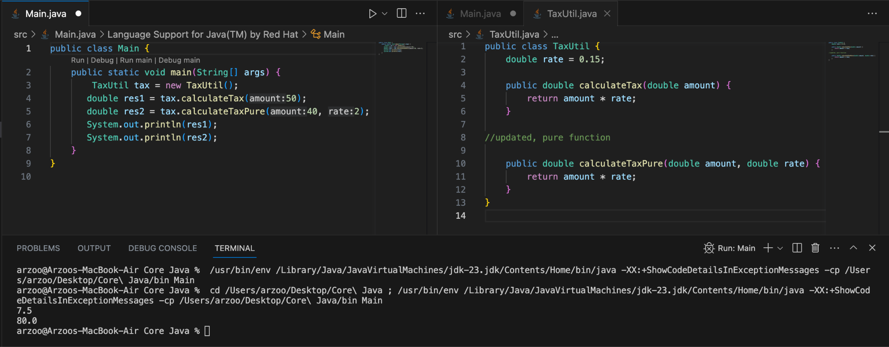

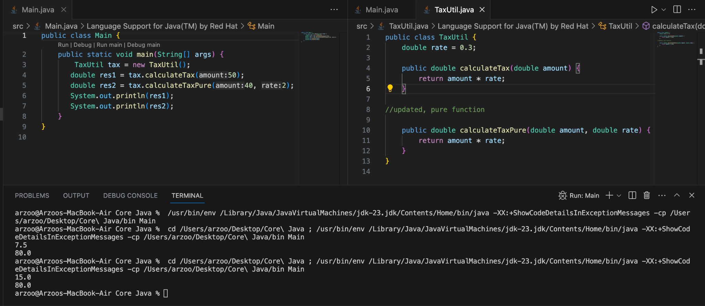

The output of the method calculateTax() changes even when the input remains same (on changing the variable rate from 0.15 to 0.3) whereas the output of the method calculateTaxPure() remains unchanged.

- Super.show() : Calls the static method show() in the Super class and prints super class show method
- new Super.StaticMethods().show() : Creates an instance of the static nested class StaticMethods, calls its instance method show() and prints sub class show method
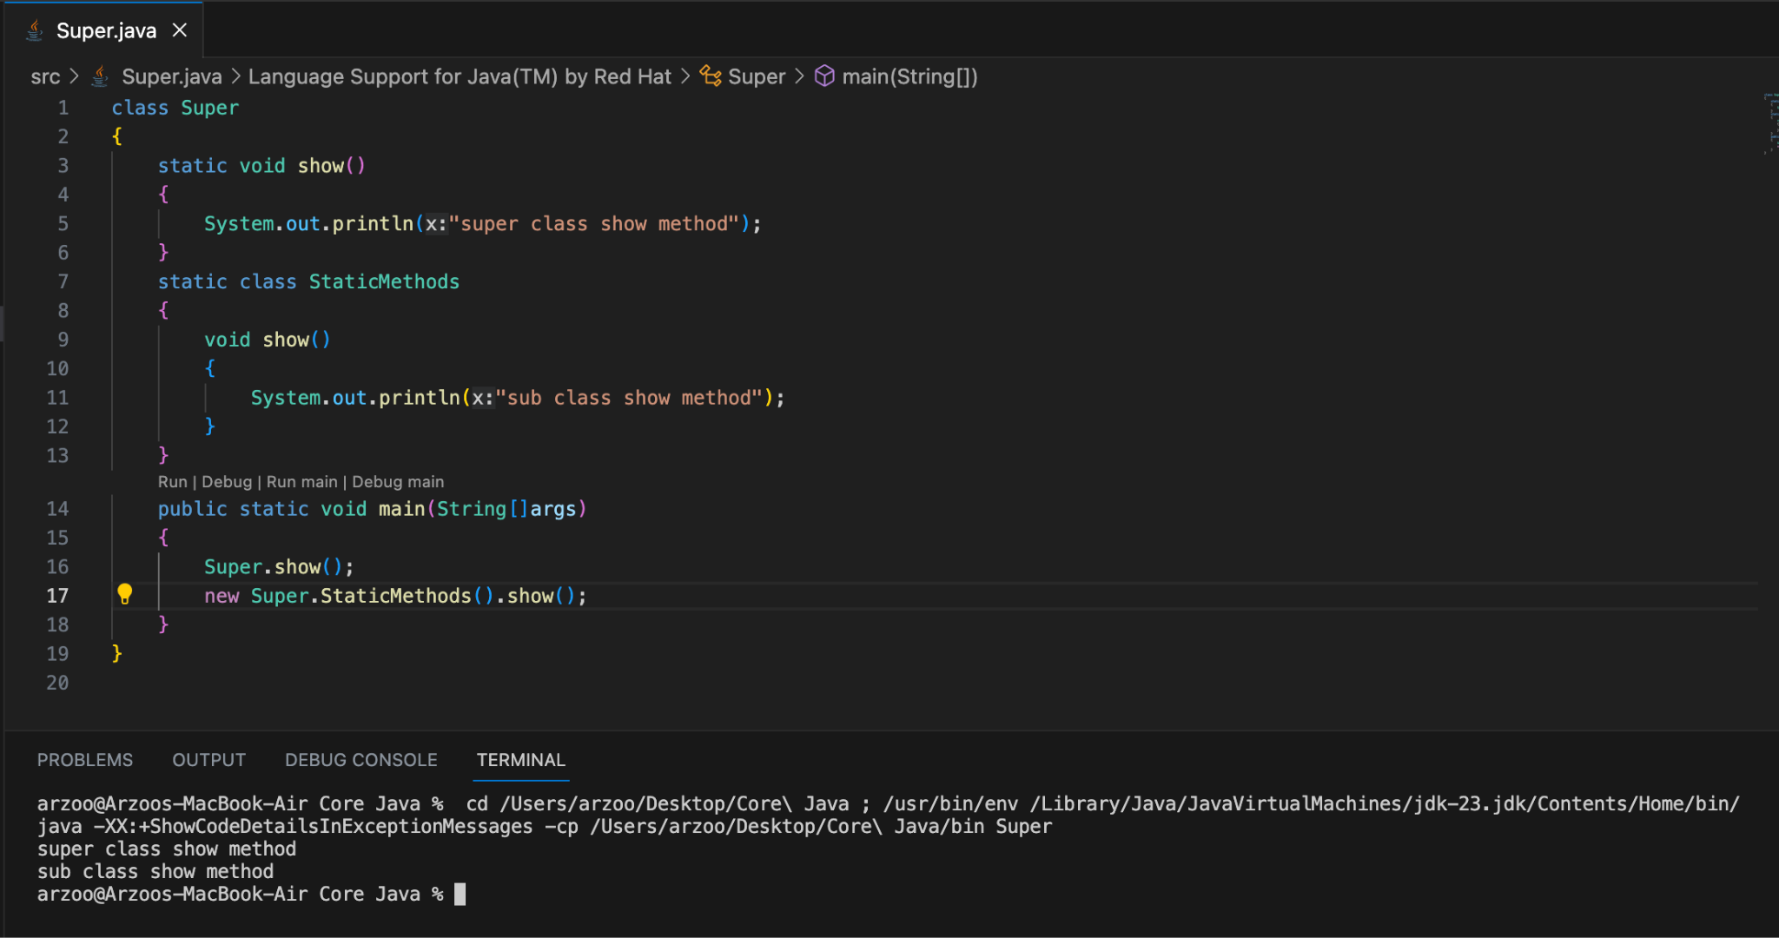

- The num field in Super2 (value 20) is shadowed by num in ThisUse (value 10), so it's never accessed here.
- this.display() and display() are identical here since they refer to the same overridden method.
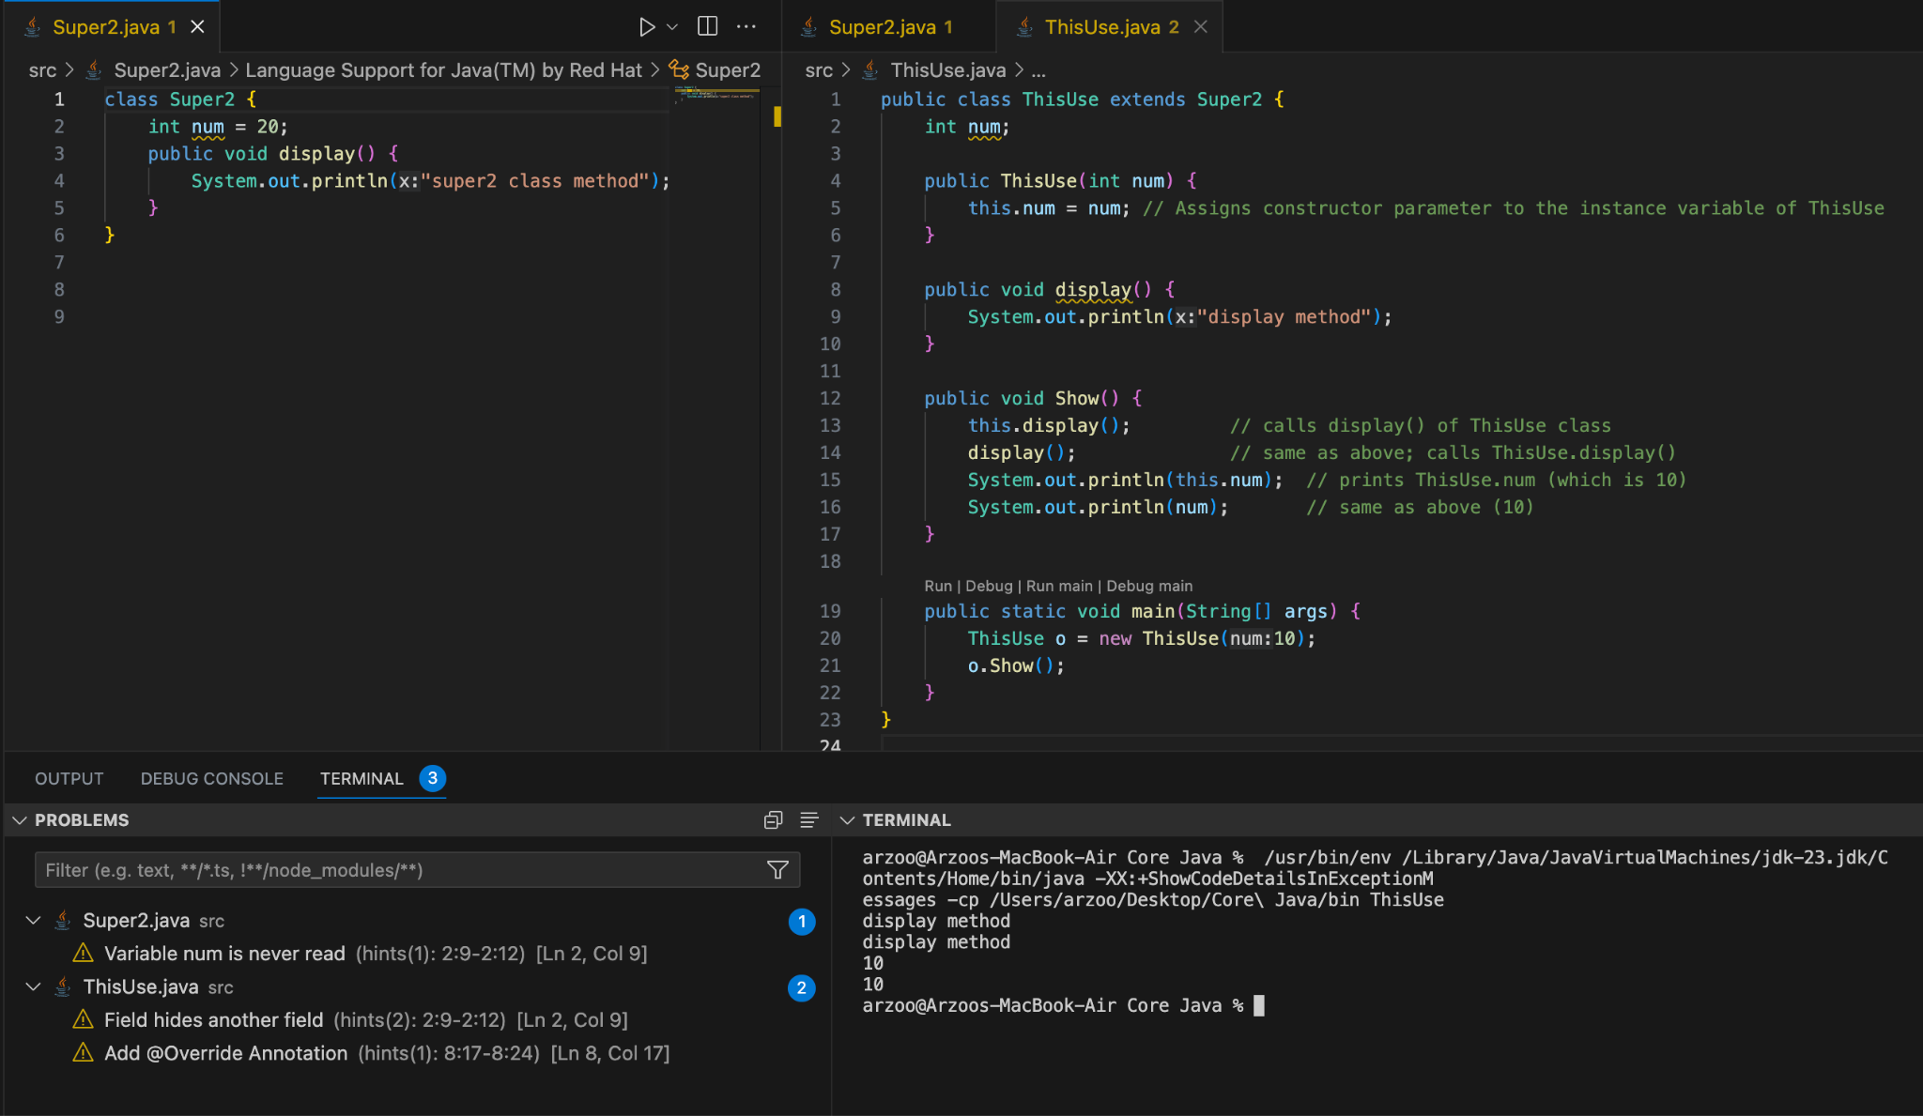

- The Singleton Pattern ensures that a class has only one instance and provides a global point of access to it. It is used when exactly one object is needed to coordinate actions across the system — such as for logging, caching, configuration, or access to hardware.
It is useful as it :
- Controls access to a shared resource.
- Saves memory by avoiding multiple instances.
- Ensures consistency (e.g., global config, logging).

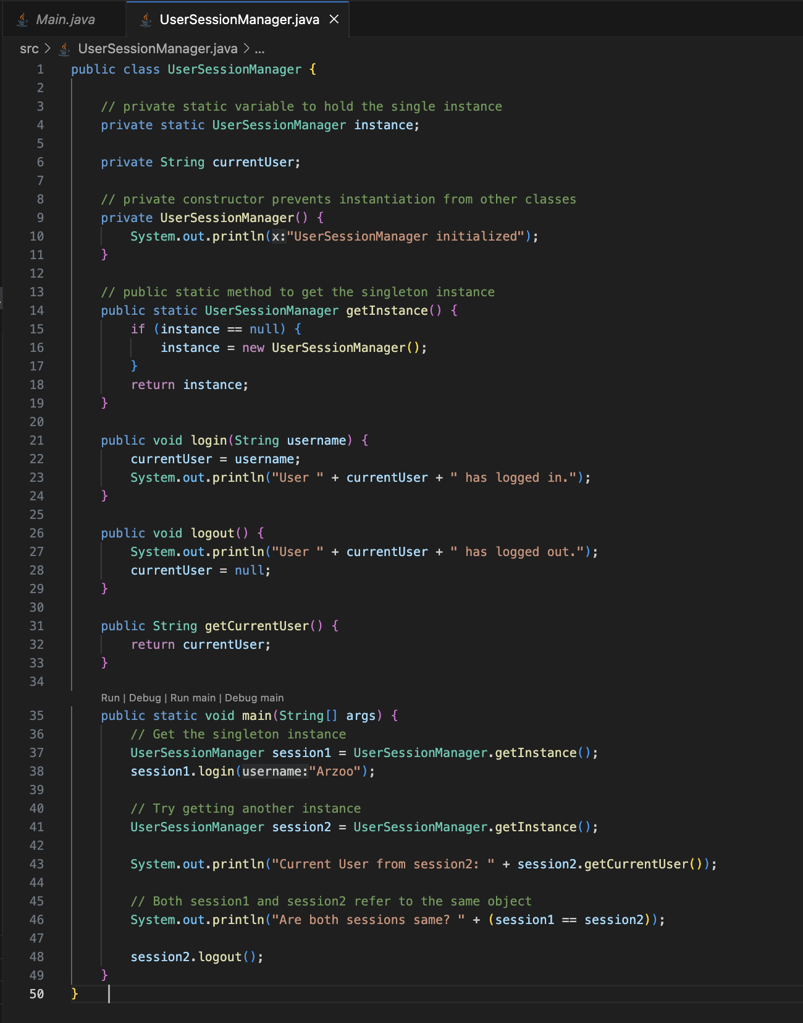
For Example:

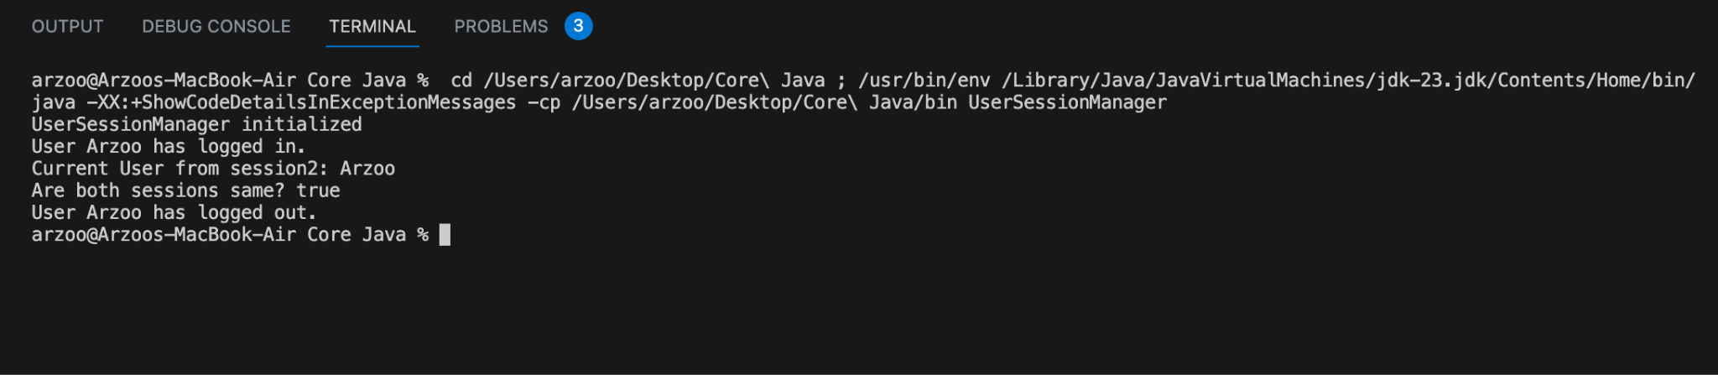

- Encapsulation is one of the fundamental principles of Object-Oriented Programming (OOP). It means binding the data (fields) and code (methods) together and restricting direct access to some components of an object. In Java, we achieve encapsulation by:
- Making fields private
- Providing public getters and setters to access and update them

Need of Encapsulation :
- Protects internal state of an object from unintended changes
- Makes code easier to maintain and modify
- Adds a layer of control over data (e.g., validation)

For Example :
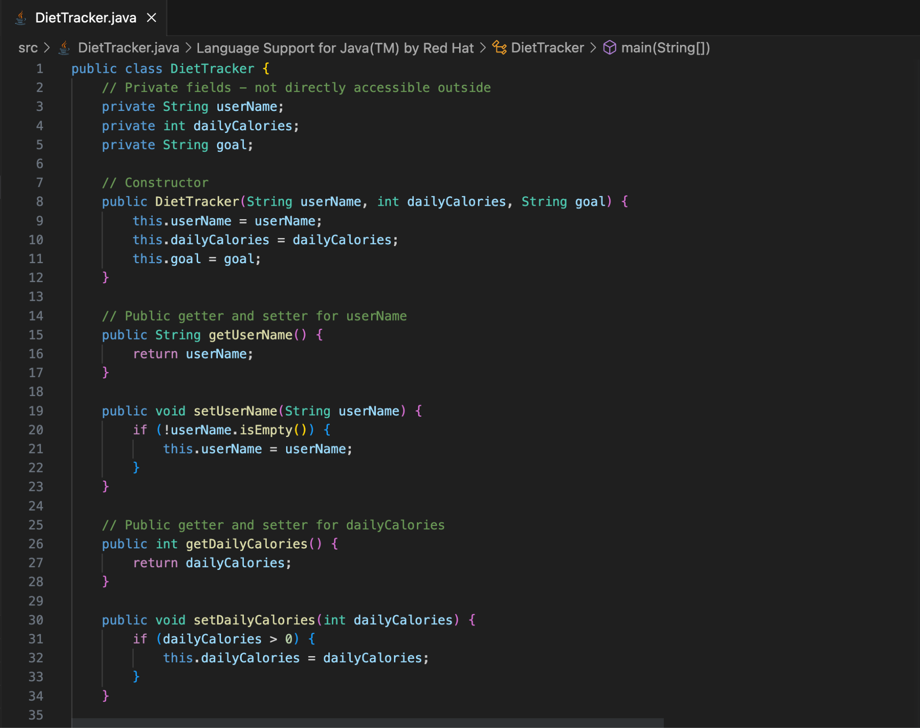

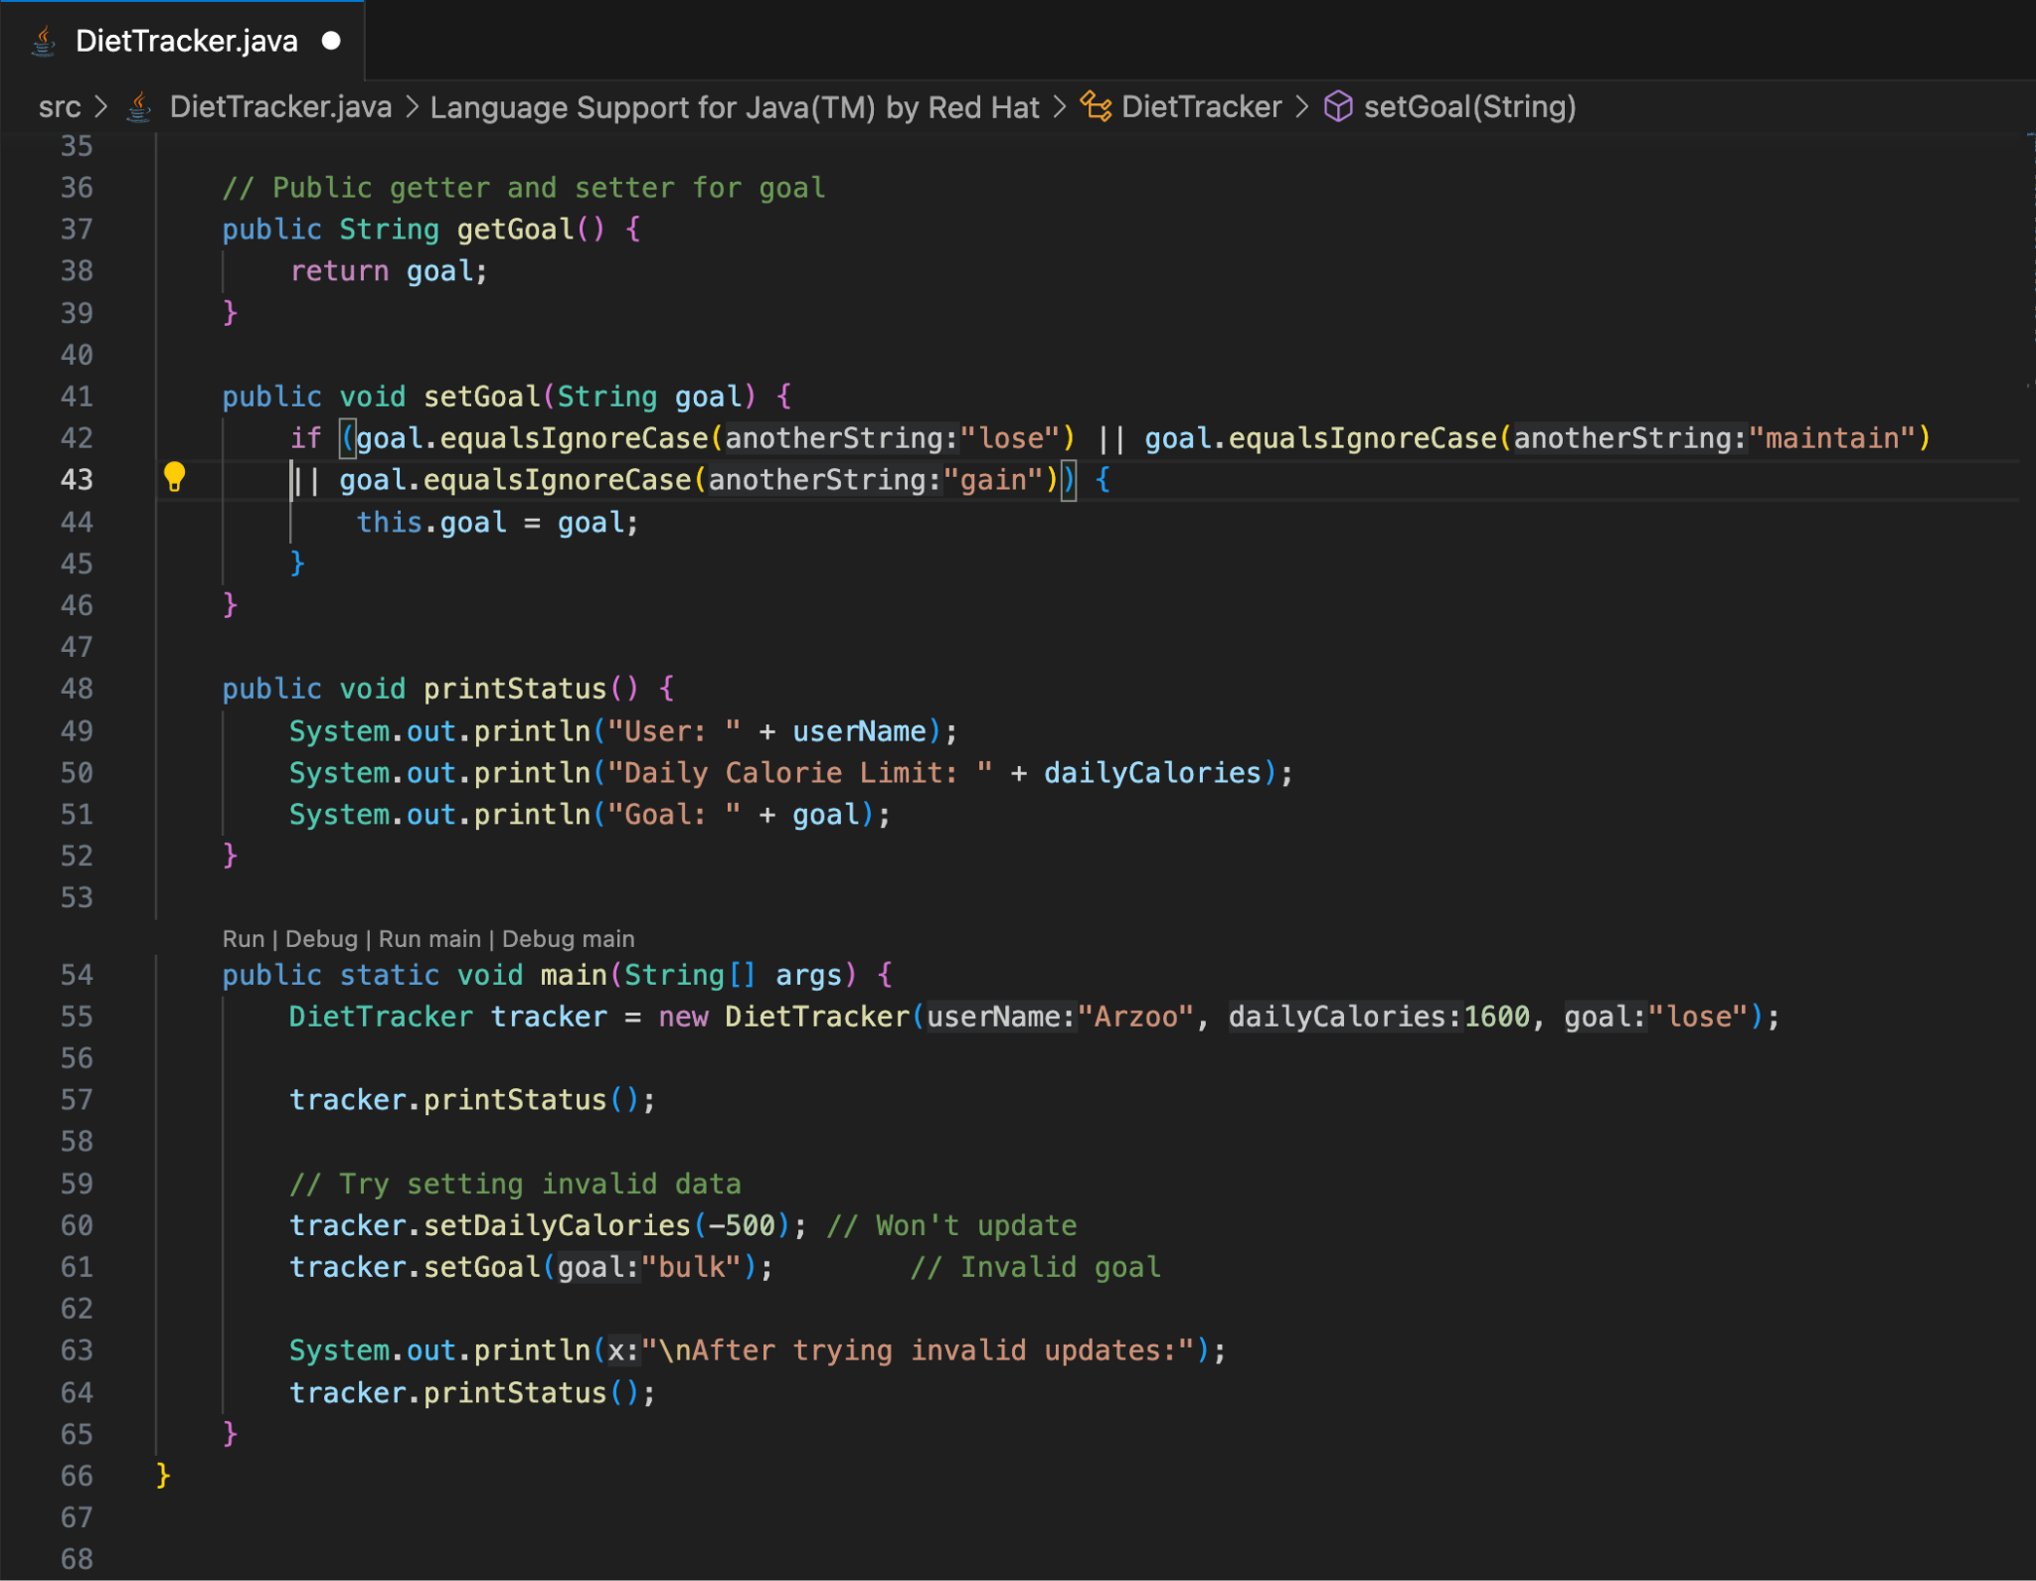

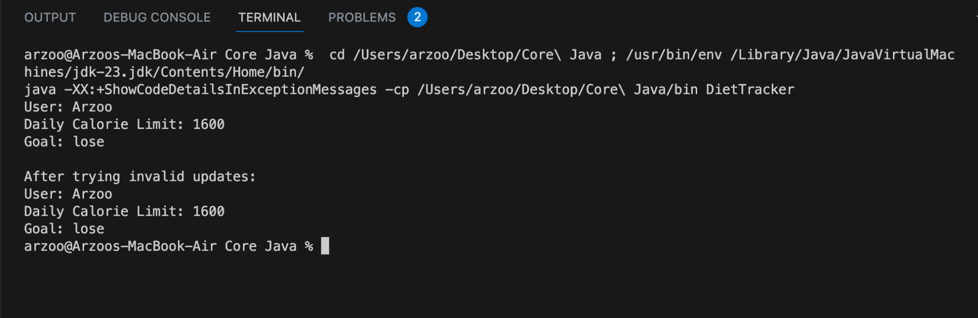

- CRUD operations (Create, Read, Update, Delete) using ArrayList in a class called EmployeeCRUD, for the given Employee class :

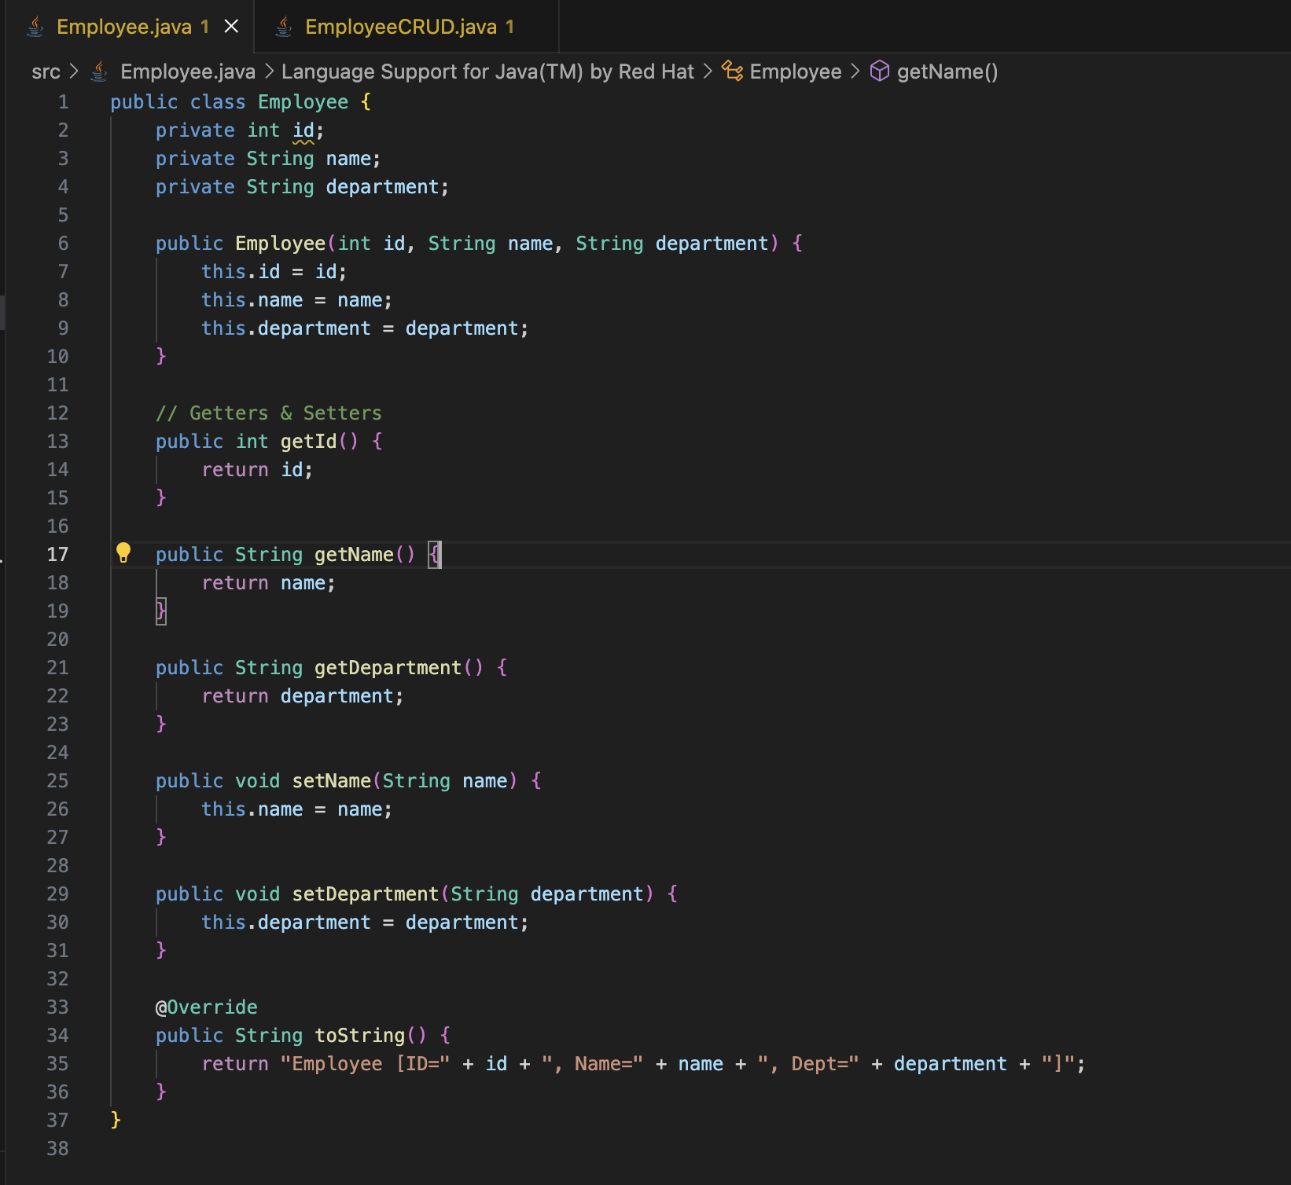

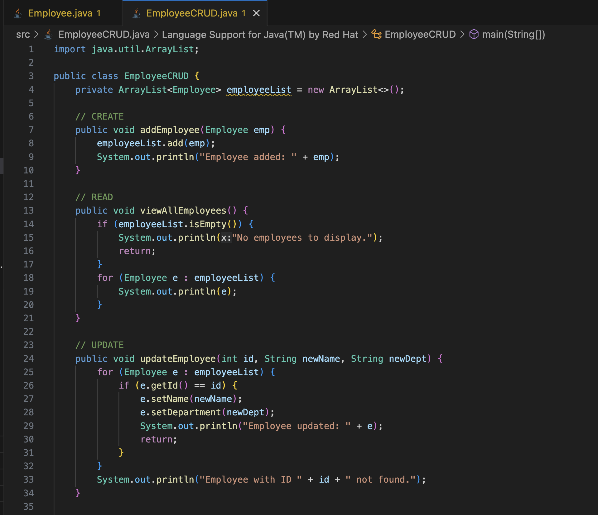

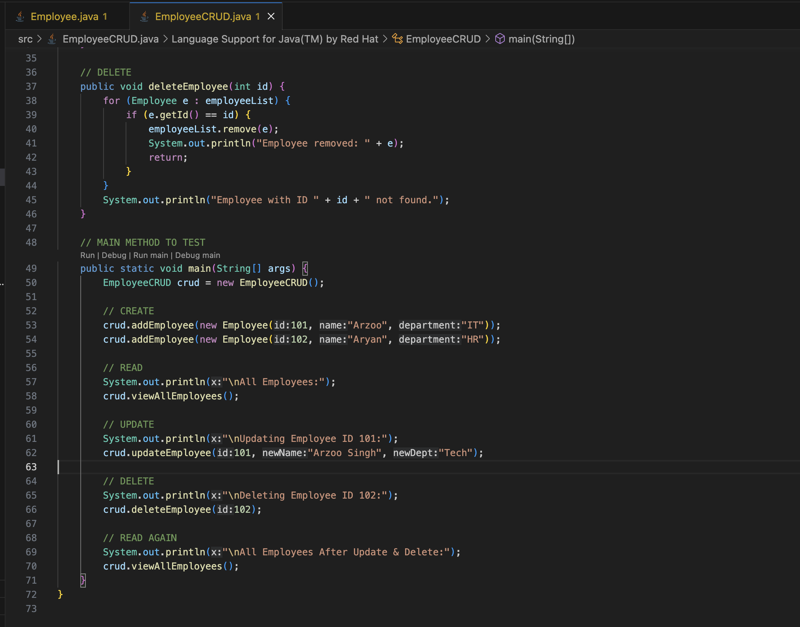

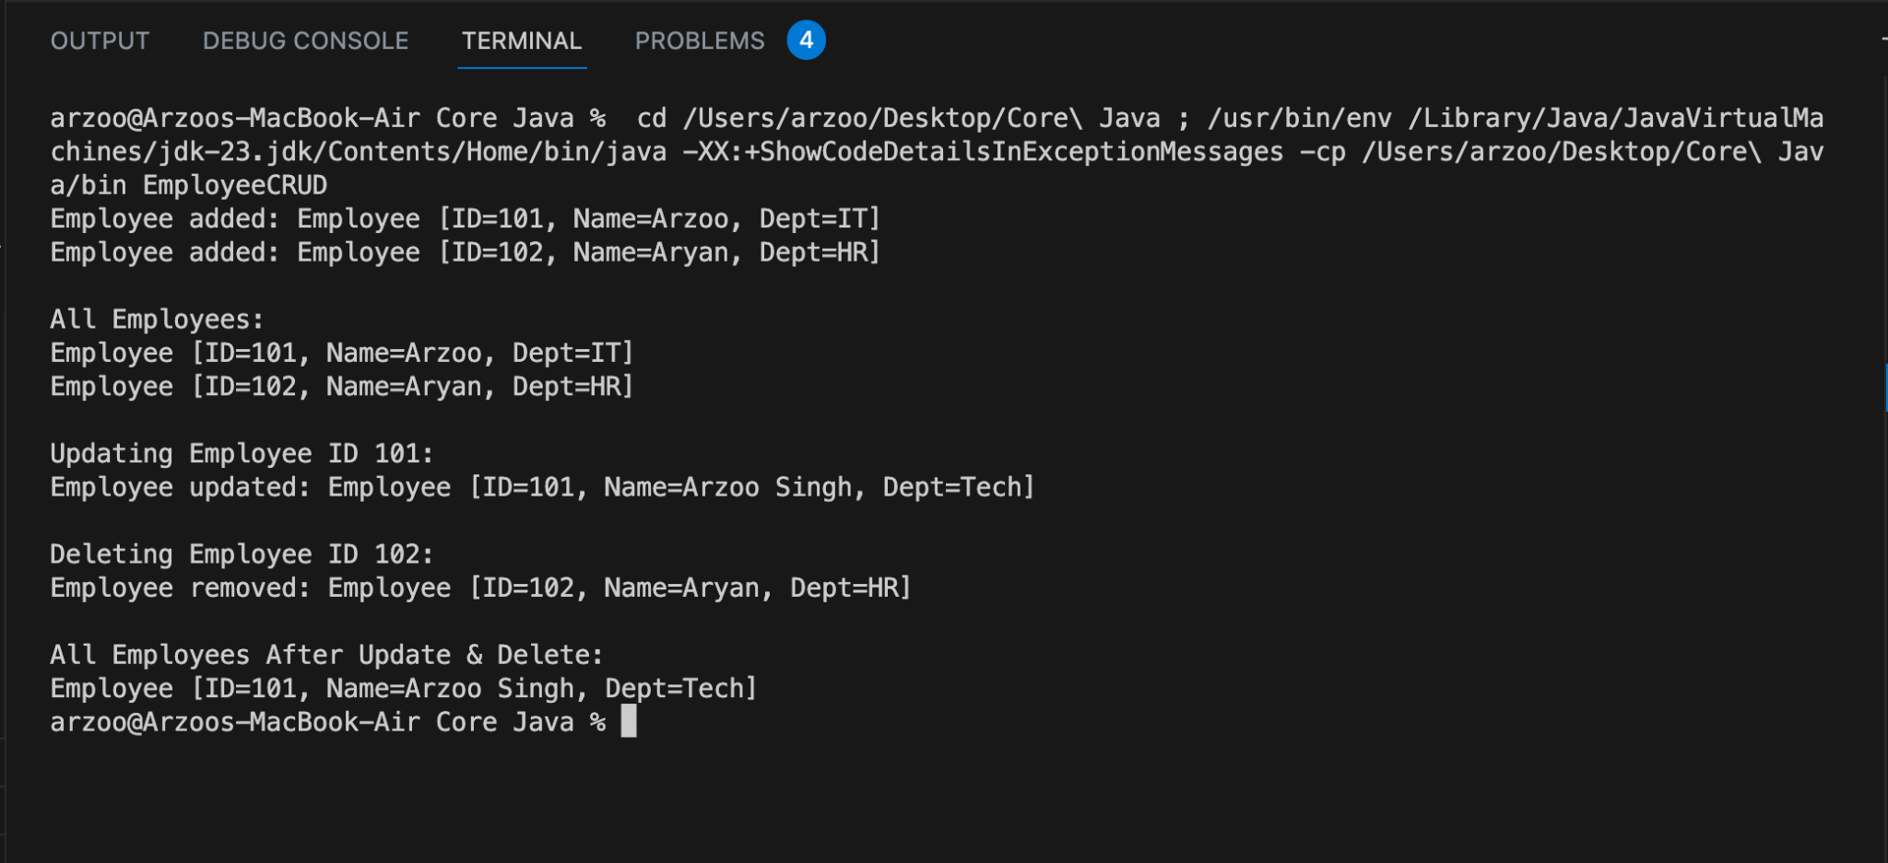

- CRUD operations using JDBC on the given Employee class :
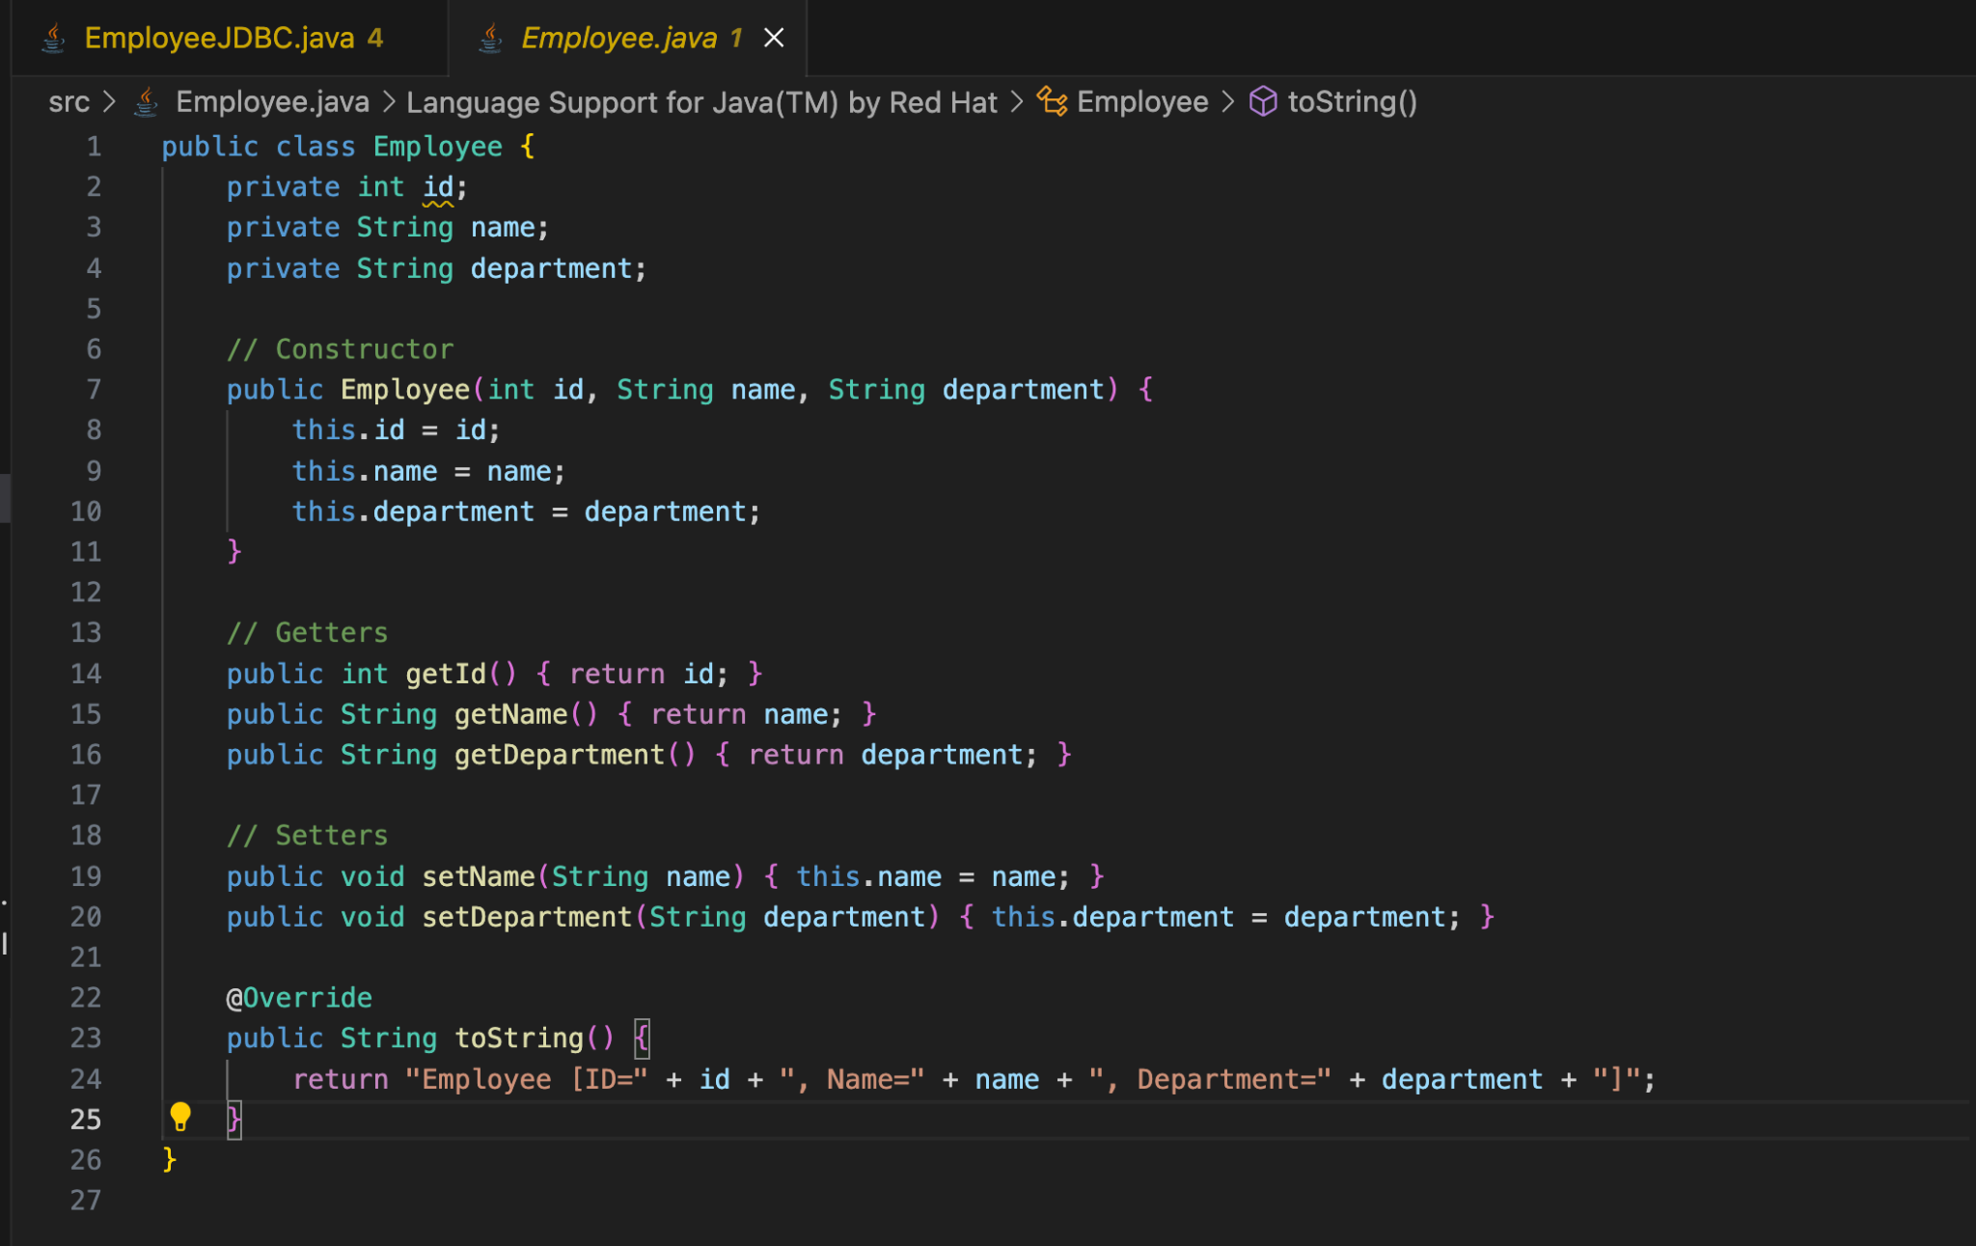

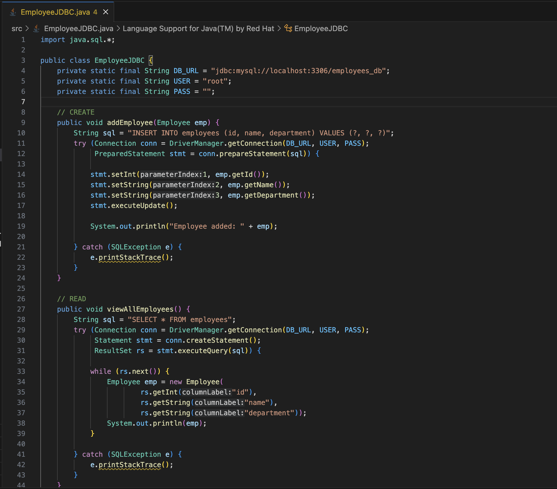

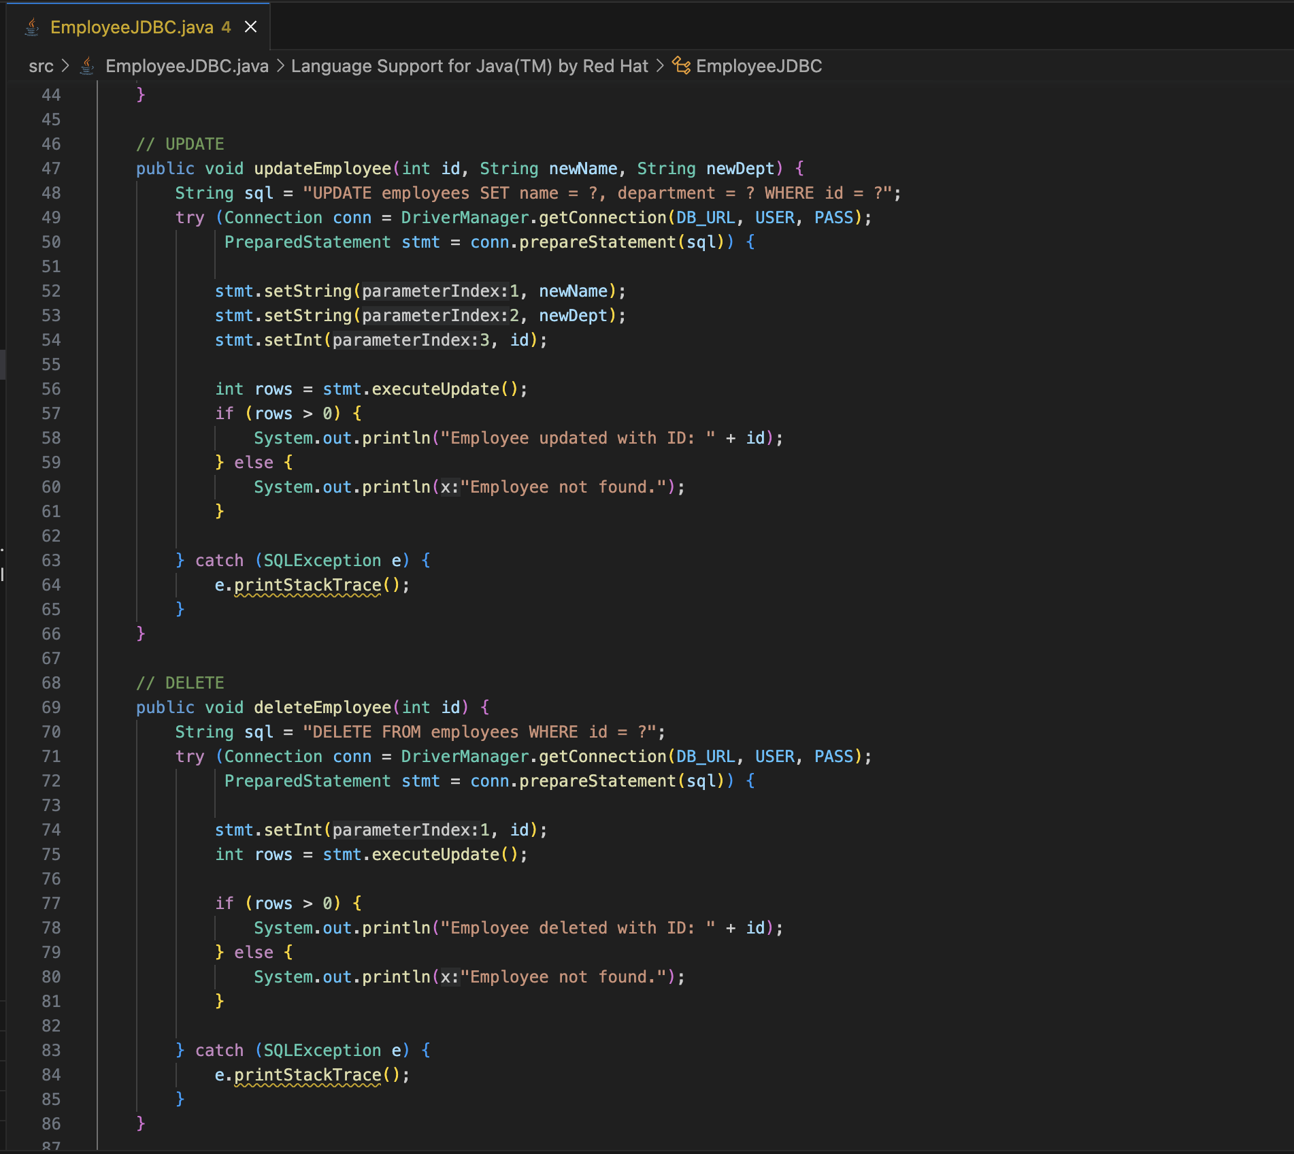

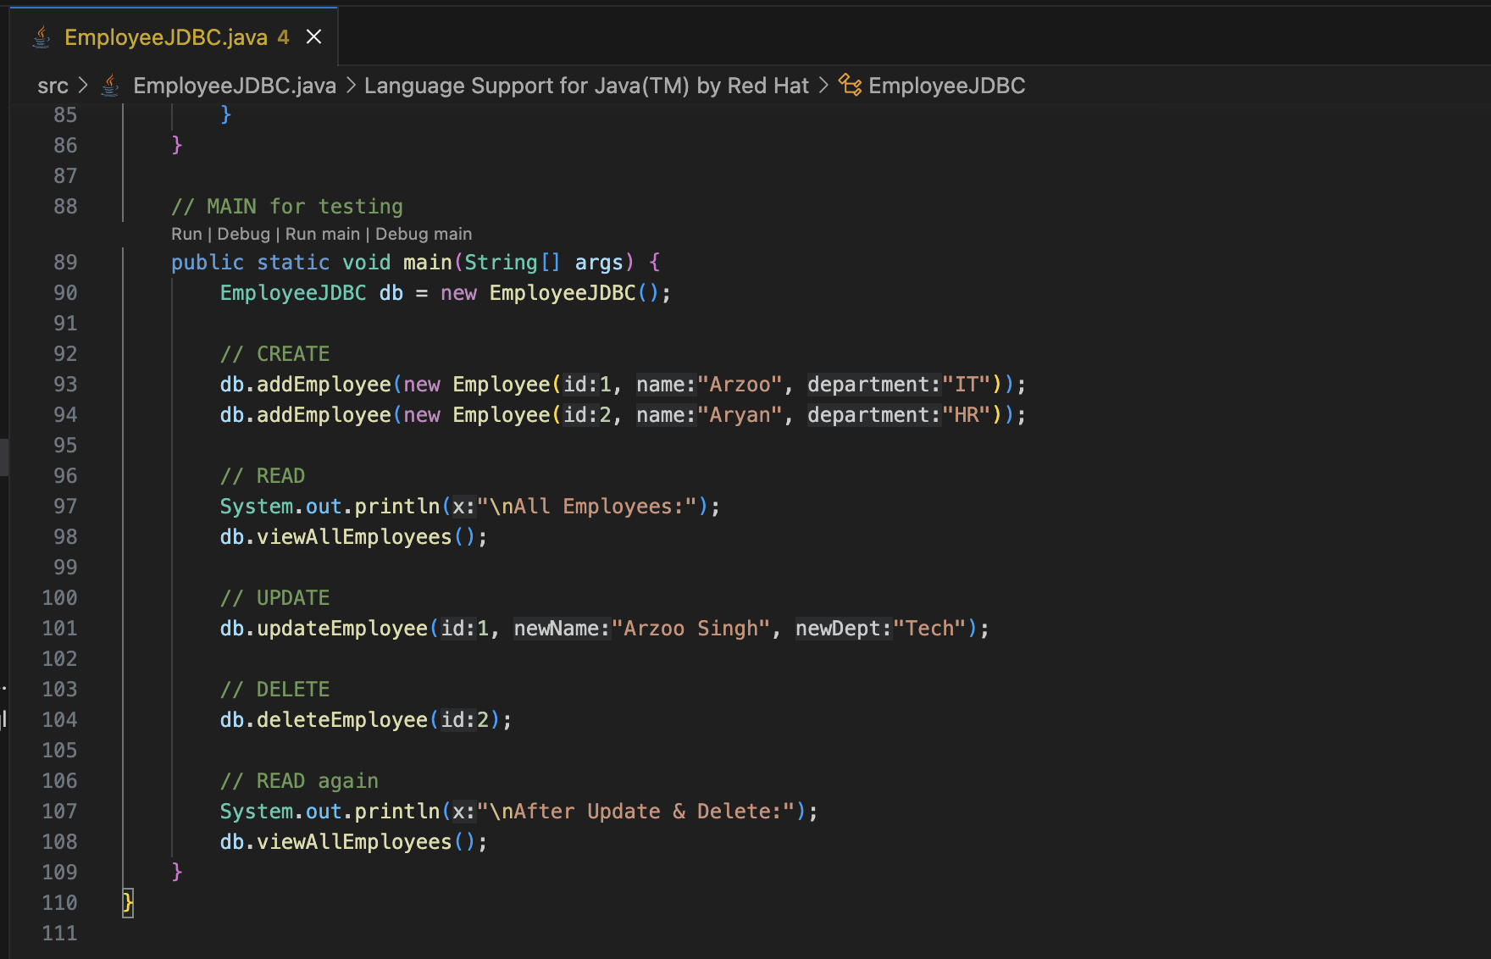

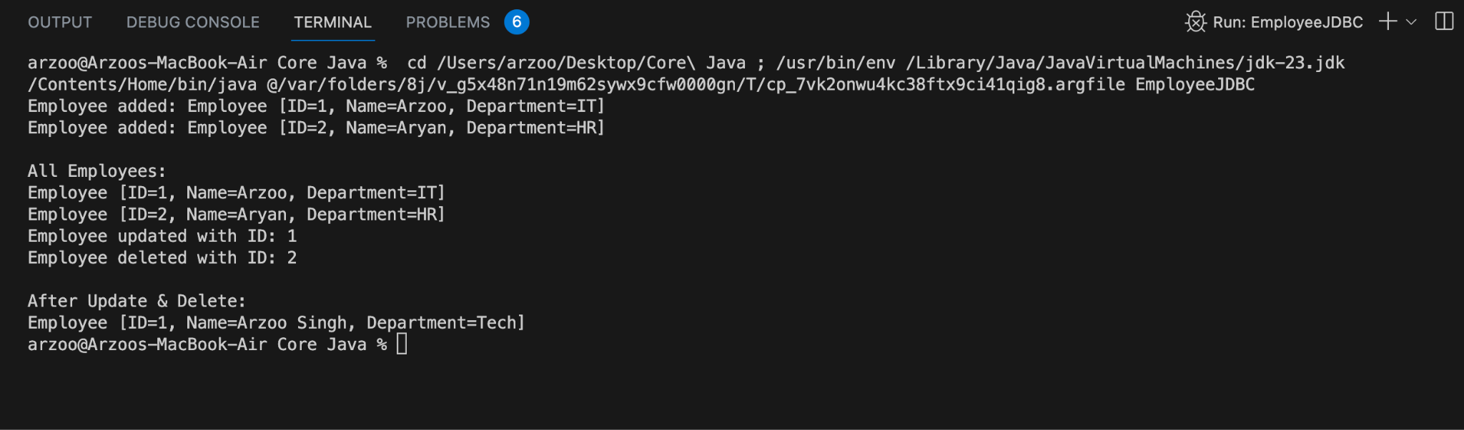

Javascript Task

